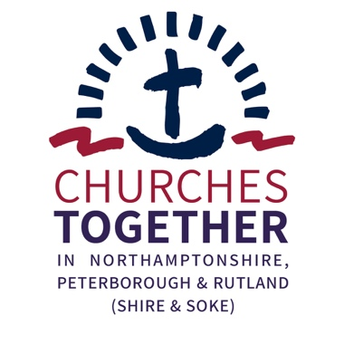
Churches Together in Northamptonshire, Peterborough and Rutland

Ecumenical Development Officer

Person Specification

Essential requirements

- A mature Christian faith with a commitment to mission and unity. (An Occupational Requirement exists for the post-holder to be a Christian in accordance with the Equality Act 2010.)

- The right to work in the UK. Those called for interview will be required to bring documentation to demonstrate that right.

- Membership in good standing of a Church eligible for membership of Churches Together in Northamptonshire, Peterborough and Rutland.

- Knowledge of recent ecumenical developments, a general knowledge of the workings of the mainstream Churches.

- Familiarity with and experience of church and ecumenical structures at local level.

- A commitment to ecumenical working and an ability to relate to a wide variety of ecclesial traditions and individual theologies, holding with integrity his/her own convictions whilst not allowing these to prejudice opinion or hinder partnership. The ability to promote critical ecumenical thinking. Some theological knowledge.

- A collaborative working style and ability to relate well to lay and ordained Christians, to Church Leaders and to colleagues. Good listening skills, good humour, discernment and approachability are key elements here, as well as discretion, tact and the ability to respect confidences. The Ecumenical Development Officer must also be able to delegate or allow others to undertake some of the work.

- A proven ability to work alone and on his/her own initiative. The Ecumenical Development Officer must be able to manage his/her own time and flexible working hours, ensuring that s/he does not yield to the temptation to overwork. Putting into place appropriate boundaries between work and personal time is crucial.

- A positive and optimistic outlook and the skill of encouraging, inspiring and supporting others. A certain amount of conflict-management may be required, so an ability to face stress is therefore necessary.

- The ability to think creatively, take initiatives and plan ahead. The Ecumenical Development Officer must be able to balance the need to fulfil core tasks with the flexibility this post offers to develop the work according to his/her own gifts and experience.

- Administrative, organisational and committee skills, including clear and accurate record-keeping, are essential.

- Skill in written and spoken communication, including addressing small and large groups with clarity. Ability to grasp complex issues and to retain objectivity in dealing with them.

- Competence in the use of a computer, e-mail and Microsoft Office or equivalent.

- The ability to visit all parts of Northamptonshire as cost-efficiently as possible within the agreed budget. (The Officer will normally live or be willing to live within reach of Northampton. Relocation expenses will not be paid.)

Desirable requirements

- Familiarity with and experience of church and ecumenical structures at national level.

- Familiarity with and experience of current practice in mission and evangelism including fresh expressions of church.

- An understanding of Black-led churches and ethnic minority churches.

- A theological qualification.

- Desktop publishing skills and the ability to maintain databases and websites.

- Familiarity with and experience of statutory authorities’ structures and ways of working and ability to relate to secular leaders.

- Own car and valid driving licence, preferably a clean one.

May 2022

