CCTL.05.08.06

CHURCHES TOGETHER IN LANCASHIRE

Review 2007/08

Final report of the Review Group, 24 April 2008

Table of Contents

1 Introduction 2
2 A slimmed-down structure for Churches Together in Lancashire 3
3 The Inter Faith Development Officer 4
4 The County Ecumenical Development Officer 5
5 Other possibilities 5
6 The Further Education Co-ordinating Chaplain 6
7 Summary of recommendations 7

Appendices

The theology of hospitality Appendix 1
Diagram showing the current Churches Together in Lancashire structure Appendix 2
Churches Together in Lancashire constitution Appendix 3
Council of Churches Together in Lancashire constitution Appendix 4
Diagram showing the proposed slimmed-down structure Appendix 5
How it might work Appendix 6
Inter Faith Officer Appendix 7
The role of the County Ecumenical Development Officer Appendix 8
Further Education Co-ordinating Chaplain Appendix 9

Introduction

  - The review of Churches Together in Lancashire began well. Discussions at the Forum meeting on 20 November 2007 indicated enthusiastic commitment to working together with an emphasis on mission, especially at local level, and acknowledgement of the importance of inter faith work. There was an appreciation of the work done by Dale Barton and Terry Garley and an awareness that Terry's retirement offered an opportunity for something of a new start, with renewed energy and a missionary focus. The question in the air, asked with anticipation of a fresh start, seemed to be: 'What now?'

  - The review group has found itself focusing on two main areas. Clearly the urgent question was one of staffing – and as we explored possibilities it became clear that the appointment of the Further Education Co-ordinating Chaplain was also an issue. Alongside staffing and inextricably entwined with it, however, was that of the structure of Churches Together in Lancashire. Our review has therefore addressed both these issues. Our recommendations on a slimmed-down structure are presented in #2 of this report and on staffing in #3ff.

  - As we engaged with these questions, we spent some time reflecting on the theme of hospitality and gifts. Henri Nouwen (“Reaching Out”) reminds us that hospitality is one of the richest biblical terms that can deepen and broaden our insight in our relationships to our fellow human beings.

“Old and New Testament stories not only show how serious our obligation is to welcome the stranger in our home, but they also tell us that guests are carrying precious gifts with them, which they are eager to reveal to a receptive host.”

“When hostility is converted in hospitality then fearful strangers can become guests revealing to their hosts the promise they are carrying with them. Then, in fact, the distinction between host and guest proves to be artificial and evaporates in the recognition of the new-found unity.”

Nouwen argues that in the context of hospitality guest and host can reveal their most precious gifts and bring new life to each other. He dares to believe that the concept of hospitality can offer a new dimension to our understanding of a healing relationship and the formation of a re-creative community in a world so visibly suffering from alienation and estrangement.

  - The context in which the Churches in Lancashire find themselves is one of rapid change. As well as technological change with its opportunities for new ways of communication and dangers of information overload, we now live in a ‘post Christian’, 'post denominational' society where there is a sharper debate between secularists and faith communities. There is fear and hostility towards the stranger and lack of peace in our institutions. The Churches themselves are changing, on the one hand congregations are older and smaller, on the other hand there is increasing variety in ethnic churches, especially with new immigration from the Eastern Europe accession countries. Denominations per se are largely irrelevant to young people and 'ecumenical' has become a bit of a 'dirty word', unattractive and off-putting. All this poses a huge challenge for the Churches – a challenge they must attempt to face together.

  - This review has attempted to look at the needs of the Churches in Lancashire in the context of this rapid change and through the lens of hospitality and receptive ecumenism. Our report is therefore based on a theological reflection on hospitality – see appendix 1.

- A slimmed-down structure for Churches Together in Lancashire

  - The current structure of Churches Together in Lancashire looks back to the last review which put into place new committees which require many meetings. Appendix 2 shows the structure in existence at present. One consequence of this is the County Ecumenical Development Officer spends much of her time administering this structure.

  - This is entirely contrary to the stress the review group has heard from all sides on the need to encourage local ecumenism for mission.

  - We are therefore suggesting that the Churches Together in Lancashire structure should focus on its three areas of work: the Further Education, Inter Faith and Ecumenical Development Groups.

  - These committees should be co-ordinated by an Executive Group consisting of representatives from each Development Group and including at least one Church Leader. The Executive Group will be the Trustees of Churches Together in Lancashire.

  - We would expect that the Church Leaders would continue to meet as they do at present.

  - The new structure combines the current Council and Forum meetings into an Assembly or Gathering and suggests that attendance should be open to all, much as happened on 20 November 2007. It also releases the new Assembly from most business matters and from the need to accept reports as a matter of course.

  - The Assembly (or whatever Churches Together in Lancashire chooses to call it) and other occasional but regular gatherings are a key part of the new structure. They should be inspirational or useful meetings, gathering people together according to theme or need.

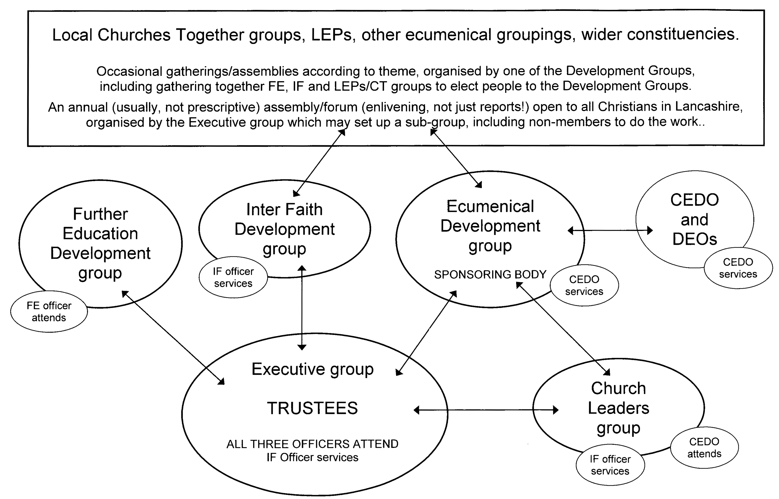

The Inter Faith Development Officer

  - Given the importance of this area of work in Lancashire, the Church Leaders have decided that this should be a full time permanent post.

  - The Review Group recommends that the terms and conditions of this post should be the same as those for the County Ecumenical Development Officer.

  - At the request of the Executive the Review Group has worked with the Inter Faith Development Committee and consulted with Churches Together in England's Inter Faith Development Officer to propose a job description for the Inter Faith Development Officer – appendix 6 of this report.

  - It is envisaged that the Inter Faith Development Officer should work in close collaboration with the Ecumenical Development Officer, especially in relation to the Executive and the Church Leaders. The Inter Faith Development Officer will, however, carry the main responsibility for servicing these groups as s/he has the full-time post.

The County Ecumenical Development Officer

  - Looking at the needs of the Churches in Lancashire through the lens of hospitality and receptive ecumenism, the emphasis on enabling the local becomes ever stronger. The review group therefore wishes to release the Ecumenical Development Officer from the administrative burden of responsibility for an office and line-managing an administrative assistant.

  - An added incentive for this change is that, if Churches Together in Lancashire continues to rent an office and keep money in the budget for an administrative assistant, there will only be enough money for a half-time Ecumenical Development Officer. If the office is closed, the Ecumenical Development Officer works from home and is responsible for his/her own administration, then the review group understands that will be enough finance for a permanent 0.8 post.

  - This pattern of work is very common in the Intermediate Bodies in England and works well in other counties. It does imply a computer-literate officer and a move away from paper to mainly electronic mailings, saving both time and money. This is now the pattern in most Intermediate Bodies in England. While some welcome this change, the review group does appreciate that others may prefer receiving hard copy through the post. However we consider that local mission and ecumenism is better served by a Ecumenical Development Officer who can spend more time at local level rather than on administrative tasks.

  - We believe, therefore, that if Churches Together in Lancashire accepts our recommendations for slimmed-down structures and less administration, the Ecumenical Development Officer and the Inter Faith Development Officer will be able to sustain the routine but necessary ecumenical and inter faith tasks yet will also have time and energy for new ideas and new ways of working to enable and encourage churches at local level for mission.

  - Appendix 8 of our report sets out what we believe is the role of the County Ecumenical Development Officer. This is based on the job description recently used most successfully by Churches Together in Cumbria in the appointment of their new half-time Ecumenical Development Officer.

  - The model of work outlined in appendix 8 would be challenging even for a full-time officer. The reality in Lancashire is that there is funding for a 0.8 post and the review group recognises that the Ecumenical Development Officer and his/her line manager will need to take care to ensure that 'nuts and bolts', though necessary, will not take precedence over the essential work of encouragement, facilitation and networking.

  - However, if Churches Together in Lancashire accepts the review group's recommendation that the Ecumenical Development Officer should be a 0.8 post, the review group considers that the model of work in appendix 8 is realistic.

Other possibilities

  - The Review group did consider other possibilities. An alternative model would be to reduce the Ecumenical Development Officer to a half-time post and to explore possibilities for an 0.3 post.

  - This post could be permanent. For example, it might be decided that Further Education is a priority and the 0.3 funding could be transferred to the Further Education Co-ordinating Chaplain to enable that to become a salaried post.

  - Alternatively, it could be short-term, eg three years, enabling Churches Together in Lancashire to focus on a particular issue or principle in each three year period. It might be decided that, for example, young people or the environment are a priority in the current situation and that a part-time post should be created to enable Churches Together groups to focus on that area of work. The advantages of this model would be that fresh energy could be injected into Churches Together in Lancashire. Alongside this, however, must be placed the recognition that it takes time for any post-holder to settle into the task and a series of short-term appointments may not be the best use of resources.

  - Reducing the Ecumenical Development Officer to a half-time post would have a major impact on the role described in appendix 8. Realistically, if the Ecumenical Development Officer were to work only half-time, s/he would only be able to service what is already in place in Lancashire and the task of development would not be possible.

  - If the Ecumenical Development Officer in Lancashire is reduced to a half-time post, member Churches would need to appoint Denominational Ecumenical Officers who are given time for the post instead of, as at present, Officers with full-time appointments in addition to their Denominational Ecumenical Officer responsibilities. Given the constraints on denominational finance and staffing, the review group considers this option unrealistic.

  - If Churches Together in Lancashire wishes to focus on a particular theme, an alternative model might be that all three of Churches Together in Lancashire's office-holders should have an emphasis on facilitating work, for example, with young people or on the environment, without losing their focus of hospitality and of enabling the Churches to work together at local level, on inter faith matters and in Further Education.

The Further Education Co-ordinating Chaplain

  - At present, the Further Education Co-ordinating Chaplain is a six-hour a week volunteer who receives an honorarium of £2000 plus 3% pa. This is, pro rata, a little less than half the salary of the two Officers employed by Churches Together in Lancashire.

  - The review group notes the request of the Further Education Development Committee for a review of the post. The review group felt unable to focus on this request since it considered it more urgent for a decision to be made on the employment of the two Officers. The paperwork is therefore presented as appendix 9 of this report.

  - The issue, as set out clearly in the Churches Together in Lancashire Executive minutes of 12 February 2008 is whether this post should move from that of a voluntary worker with an honorarium, as at present, to that of a salaried employee.

  - The review group notes the possibility of obtaining external funding for this post.

Summary of recommendations

  - The Executive should make arrangements, according to the current constitution, for Churches Together in Lancashire to slim down its structures as recommended in #above, in appendices 5 and 6 and, inter alia, in appendix 8.

  - The Executive should, as soon as possible, register Churches Together in Lancashire as a charity (cf footnote Error: Reference source not found 3) and consider protecting the personal liability of its Trustees by, for example, becoming a Company Limited by Guarantee (cf footnote 6 3).

  - As a matter of urgency, Churches Together in Lancashire should regularise its employer status as outlined in footnote 7 3.

  - In order to increase the finance available for Officer salaries, the currently vacant post of Administrative Assistant be discontinued and the office closed, making it a requirement of any office-holder that s/he work from home – see #4.a, #4.b, and #above.

  - The Executive should be tasked to set up, as soon as possible, a group charged with responsibility for advertising for, interviewing and appointing a full time Inter Faith Officer for Churches Together in Lancashire as recommended in #above and in appendix 6.

  - This same group should also take responsibility for advertising for, interviewing and appointing an 0.8 Ecumenical Development Officer as recommended in #above and in appendix 8.

  - Once these two appointments are in place and decisions have been made about slimmed-down structures, the Executive should review the post of Further Education Co-ordinating Chaplain (see #above and appendix 9). Specifically, a decision should be made about whether to convert this volunteer-in-receipts-of-an-honorarium post to that of a salaried employee in the light of Churches Together in Lancashire's financial resources after the possibilities of external funding have been explored.

24 April 2008

Review Group members • Rt Revd Geoff Pearson (Church of England, Anglican Bishop of Lancaster) • Cllr Mrs Valerie Wilson (Church of England, previous Chair of Council, Lancs County Councillor) • Revd Robert Canham (URC, past chair of Churches Together in Lancashire Council, Executive member) • Rev Michael Waters (RC, member of the Inter Faith Development Committee, member of the 2002 review of the Inter Faith Development Officer's post) • Jenny Bond (Field Officer, North and Midlands, Churches Together in England) • Rev Terence Young (Methodist, retired minister, former Denominational Ecumenical Officer and convenor of the review group)
Archbishop Rowan Williams addressed the 2003 Forum of Churches Together in England on the theme of radical hospitality. (He was not talking about Eucharistic hospitality.) Receptive Ecumenism, with its focus on gifts offered by and needed by different denominations, was also the theme of a major international conference in Durham in January 2006 and of a research project taking place in the North East which is sponsored both by the Churches and by Durham University.
Genesis 181-15, 1 Kings 179-24, Luke 2413-35.
An A4 version of the diagram on the following page, which shows the proposed new structure, is attached as appendix 5. An amplification of our recommendations is contained in appendix 6. Appendix 8, while focusing on the role of the Ecumenical Development Officer, also indicates our thinking on the role of the Executive etc.
We have re-named these Committees shown at the bottom of the current structure diagram (appendix 2). We understand that the working groups shown alongside them have ceased to exist and note that if they are needed, the Executive Group could re-establish them at any point.
Charitable status: Intermediate Bodies in receipt of more than £100k will soon be required to register as Charities. Churches Together in Lancashire's Executive is aware of the issue. It is likely that the current constitution of Churches Together in Lancashire and its Council (Appendices 2 and 3) will need to be rewritten according to Charity Commission norms and a more easily changed document be produced to regulate how Churches Together in Lancashire actually wishes to function. Churches Together in England can help with this.
A related question is that of Trustee liability. Churches Together in Lancashire is advised to consider becoming a Company Limited by Guarantee to protect its Trustees in the event of litigation.
Employment responsibilities: It has come to the attention of the review group that Churches Together in Lancashire is not the legal employer of the County Ecumenical Development Officer but that employment has been arranged through the Anglican Diocese of Blackburn. The review group is extremely unhappy about this arrangement and its consequences for legal responsibility for the employee. Questions arise about who has signed contracts, whether employer liability insurance is in place and who would be liable should the employee or someone harmed by the employee take legal action against the employer. Most other Intermediate Bodies act as the employer of their officers and the review group recommends that Churches Together in Lancashire does likewise.
The post has been vacant for some time now.
The Ecumenical Development Officer in Cumbria works alongside a half-time Social Responsibility Development Officer. In Lancashire this role is part of the Ecumenical Development Officer's brief so the posts are not entirely parallel.
The Review Group did not have access to the Further Education Co-ordinating Chaplain's terms and conditions, but on the assumption that they are similar to that of the Ecumenical Development Officer with regard to holidays and expenses etc, our calculations are as follows: The Ecumenical Development Officer's salary for 2008 is £28,781. (This figure seems to include the employer's pension contributions.) The Ecumenical Development Officer works 35 hours a week and the Further Education Co-ordinating Chaplain six hours a week. A pro rata salary would be £4,993.89. The honorarium for 2008 is £2,122.00, 0.43% of the salary.
It makes sense for one group to take responsibility for this, enabling simultaneous advertising for maximum impact and minimum cost and ensuring coherence of paperwork and methodology. This group may, however, wish to appoint two different shortlisting and interviewing panels although some overlap would be desirable.

