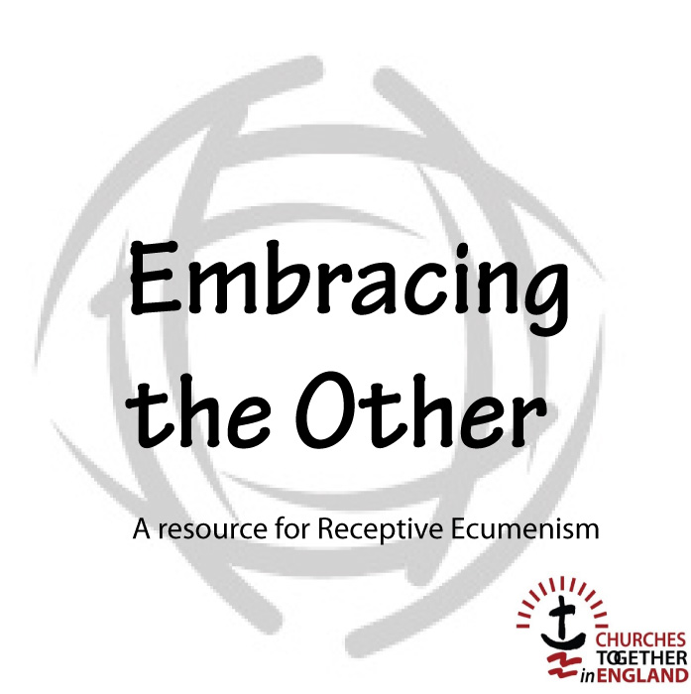

Participant’s

Stand-alone Session

Introduction

‘Receptive Ecumenism is both a way of thinking and a process that enables unity to be built by receiving gifts from others. It challenges us to not think of what others might benefit from receiving from us but instead invites us to recognize our needs and to put ourselves in the place of being a recipient.’

This material is designed to explore Receptive Ecumenism interactively. It employs both individual and collective exercises.

It is designed for use with groups of various sizes, normally in the context of a Churches Together Group or a Local Ecumenical Partnership. It could, however, be used in a variety of other settings, such as gatherings of church leaders or within the congregation of one tradition where other traditions are present.

There is also a five-session version of this material available that can be used as a Lent study course, for example.

Presenting Receptive Ecumenism

1. Welcome and introduction

2. Getting to know one another
Share your church background and something of your personal journey.

3. Setting the scene

4. Images of the church

Reflecting on three images of the church:
a building,
a garden,
a body.

5. Discussion

The church as a building –
What are the strengths of this image? What are its weaknesses?

The church as a garden –
What makes a good garden? What makes for health?

The church as a body –
What makes the body alive? What makes a body sick?

6. Break for refreshments

7. Continue to discuss

How do you see the ideas of church that we have explored applying to your own church? Or how would it apply among the churches where you live? Or to your Churches Together group?

In what areas of our life as a church, do we need to learn?

In the group share what you think you need to learn.

8. Plenary Discussion

9. The Future – working together?

Audio input

10. Discussion

What kinds of scenarios might evolve in your church, town area, city or country?

What would need to happen for the best possibilities to be achieved?

11. Closing prayer of dedication

Lord our God,
we are amazed by your love displayed in Jesus
who died in agony and rose in joy for us.
As we learn from one another, we long to see the fullness of his life
displayed likewise in his church and throughout the world.
In the power of your Holy Spirit we dedicate ourselves
to discover the gifts of our fellow Christians
so that the whole Body of Christ may flourish in every possible way
and we be made ready to give an account to others
of the hope that is in us;
in the name of Jesus.
Amen.

