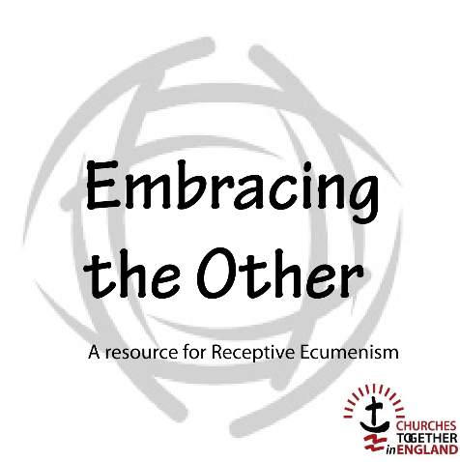

Stand-alone Session
Facilitator’s Guide

Introduction

For this facilitator’s version to be used as it has been designed, it should be consulted before the session takes place. Things that the facilitator should consider are in red. Other text (in black) is the text of the handout for participants.

‘Receptive Ecumenism is both a way of thinking and a process that enables unity to be built by receiving gifts from others. It challenges us to not think of what others might benefit from receiving from us but instead invites us to recognize our needs and to put ourselves
in the place of being a recipient.’

This material is designed to explore Receptive Ecumenism interactively. It employs both individual and collective exercises.

It is designed for use with groups of various sizes, normally in the context of a Churches Together Group or a Local Ecumenical Partnership. It could, however, be used in a variety of other settings, such as gatherings of church leaders or within the congregation of one tradition where other traditions are present.

A good deal depends on the facilitator who may need to adapt the material to take into account the size and make-up of the group or in order to respond to the direction the group is taking.

There is also a five-session version of this material available that can be used as a Lent study course, for example.

Photographs and videos for this session can be found here.

Presenting Receptive Ecumenism

Equipment needed: a flipchart for sections 5 and 8.
This session has been constructed to have two forty-five-minute halves with a thirty-minute break. Timings are for guidance only.

1. Welcome and introduction
The facilitator should introduce some background to Receptive Ecumenism; perhaps begin by asking how many people are familiar with it. If needed, the facilitator can find some introductory information about Receptive Ecumenism here.

2. Getting to know one another
Share your church background and something of your personal journey.
Depending on the size of group, this can be in plenary if the whole group is no more than about eight people or if more than eight, in small groups of about five people. It would be helpful to ensure a good ecumenical spread within each group.

3. Setting the scene
Explain what is going to happen in the session. Provide some background information about how Receptive Ecumenism has developed, refer to the outline document that can be found here.

This is a good point to invite people to be silent and commit to God what you are about to share. A short invitation to the Holy Spirit to be present may be used.

4. Images of the church

Reflecting on three images of the church:
a building,
a garden,
a body.
Input is given by the facilitator using images and readings. A selection of readings can be taken from the following – for a building: 1 Corinthians 3:11-17, 2 Corinthians 6:14-18, Ephesians 2:19-22; for a garden: John 15:1-11, 1 Corinthians 3:6-9; for a body: Romans 12:4-10, 1 Corinthians 12:11-31; Colossians 1:15-20.

Each of these three kinds of image of the church has a biblical basis, especially in the letters of Paul. Paul’s use of body and building language is particularly developed, though he does use the imagery of planting and growth (1 Corinthians 3:6-9). The picture of a garden is used by modern writers on spirituality and the church, and agricultural pictures are spread throughout the Bible as ways of talking of God’s people. Jesus, of course, often used such pictures to speak of the kingdom.

5. Discussion
Brainstorm in plenary to look at how each of the different images represents the church. A flipchart may be useful for this.

Photographs of the images can be found here.

The church as a building –
What are the strengths of this image? What are its weaknesses?

The church as a garden –
What makes a good garden? What makes for health?
Note: there are three images of a garden: one manicured, one overgrown, one half-dead.

The church as a body –
What makes the body alive? What makes a body sick?

6. Break for refreshments
A break of 30 minutes would encourage informal sharing.

7. Continue to discuss
In the small groups (or plenary if the whole group is small)

How do you see the ideas of church that we have explored applying to your own church? Or how would it apply among the churches where you live? Or to your Churches Together group?

In what areas of our life as a church, do we need to learn?
It may be good to do this as a two-minute time of silent reflection.

In the group share what you think you need to learn.

8. Plenary Discussion
a) If the meeting did go into smaller groups, share in plenary what was said in them. Write up (on a flipchart) comments from each tradition's background. Otherwise, move straight to point b).

b) Brainstorm on what gets in the way of change. The flipchart may be useful here.

c) Go into buzz groups of up to three people briefly (if appropriate) and look at experiences of how these things may have been overcome in the past.

9. The Future – working together?

Audio input
Listen to the audio clip about different scenarios presented in a ‘Radio Report’ available here .

10. Discussion
This is envisaged as taking place in plenary but, at the facilitator’s discretion, it could be in returning to the small groups where images of the church were discussed. Either way, the following questions can be use:

What kinds of scenarios might evolve in your church, town area, city or country?

What would need to happen for the best possibilities to be achieved?
Feedback in plenary the work on these questions has been done in small groups.

11. Closing prayer of dedication
The following prayer is suggested to conclude the session.

Lord our God,
we are amazed by your love displayed in Jesus
who died in agony and rose in joy for us.
As we learn from one another, we long to see the fullness of his life
displayed likewise in his church and throughout the world.
In the power of your Holy Spirit we dedicate ourselves
to discover the gifts of our fellow Christians
so that the whole Body of Christ may flourish in every possible way
and we be made ready to give an account to others
of the hope that is in us;
in the name of Jesus.
Amen.

