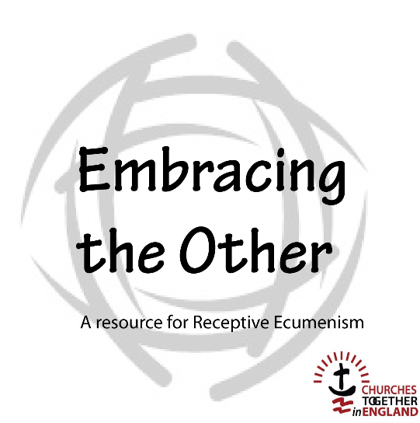

Five-Session Course
Participant’s version

Introduction

‘Receptive Ecumenism is both a way of thinking and a process that enables unity to be built by receiving gifts from others. It challenges us to not think of what others might benefit from receiving from us but instead invites us to recognize our needs and to put ourselves
in the place of being a recipient.’

This material is designed to explore Receptive Ecumenism interactively. It employs both individual and collective exercises.

This is a course of five one-and-a-half hour sessions that may be used as a Lent course or at any other time of the year. It is designed for use with groups of various sizes, normally in the context of a Churches Together Group or a Local Ecumenical Partnership. It could, however, be used in a variety of other settings, such as gatherings of church leaders or within the congregation of one tradition where other traditions are present.

Session One
Presenting Receptive Ecumenism

1. Welcome and introduction

2. Getting to know one another
Share your church background and something of your personal journey.

3. Setting the scene

4. Images of the church

Reflecting on three images of the church:
a building,
a garden,
a body.

5. Discussion

The church as a building –
What are the strengths of this image? What are its weaknesses?

The church as a garden –
What makes a good garden? What makes for health?

The church as a body –
What makes the body alive? What makes a body sick?

6. Continue to discuss

How do you see the ideas of church that we have explored applying to your own church? Or how would it apply among the churches where you live? Or to your Churches Together Group?

In what areas of our life as a church, do we need to learn?

In the group share what you think you need to learn.

7. Plenary Discussion

8. Prayer of dedication

Lord our God,
we wonder at the beauty that you are and that you have given your church
and, at the same time, we confess that we do not always act
in accordance with the Spirit’s beauty in us and among us.
In the power of that same Spirit we dedicate ourselves
to discover the gifts of our fellow Christians
so that the whole Body of Christ may flourish in every possible way
and we be made ready to give an account to others
of the hope that is in us;
in the name of Jesus.
Amen.

Session Two
Giving an account of the hope that is in us

1. Silent or spoken prayer

2. Reading – 1 Peter 3:13-17

3. Sharing together

4. Communicating our deepest hopes as people of faith

Video Input

Silent reflection

In groups consider:
What hopes do we draw from our faith and how and where are those hopes rooted?

5. Returning to plenary

Share and record the hopes and roots of hopes.

6. Consider and share

What have I learned from hearing the hopes of others?

How can my church learn from the hopes expressed?

8. Prayer of dedication

Lord our God,
you ﬁll us with hope in the abundance of your love
and all the gifts you shower upon us in your church.
We recognize our need for one another
to heal our weakness and enlighten our confusion.
In the power of your Holy Spirit we dedicate ourselves
to discover the gifts of our fellow Christians
so that the whole Body of Christ may flourish in every possible way
and we be made ready to give an account to others
of the hope that is in us;
in the name of Jesus.
Amen.

Session Three
Learning to Listen

1. Silent or spoken prayer

2. Sharing together

4. The need to Listen

Video input is followed by reflection.
Are there situations where either I did not listen or where I was not listened to.
What stops me from listening?

5. An act of transition

We take a bowl of water and read Romans 6: 1-11 to remind us of our new life in Christ.

6. The quality of God’s listening to us and how, being made in the image of God, we should listen to one another

In groups, share reflections on the following thoughts:
Jesus loves us by becoming one of us, and taking on himself not only our human nature, but our suffering and sin on the cross – what do we learn from that?
What do we learn about how we should behave with one another?

7. Video input

8. Individual work

Write yourself a letter or short paragraph about something new you might want to do or something you would want to change so that you might be able to listen more deeply.

9. Plenary reflection

What reflections do we have about our collective listening as churches?

10. Prayer of dedication

Lord our God,
your ears are always open to hear the cries of the world,
and with a tender heart you care for our needs.
Help us to listen to one another with the same attention
and so discern the wonders you work among us.
In the power of your Holy Spirit we dedicate ourselves
to discover the gifts of our fellow Christians
so that the whole Body of Christ may flourish in every possible way
and we be made ready to give an account to others of the hope that is in us; in the name of Jesus. Amen.
Session Four
Listening to Learn

1. Silent or spoken prayer

2. Group sharing

3. Video input

4. In church/denominational groups
Look at what you believe the particular strengths of your tradition may be.

5. In mixed groups of twos or threes

Present to one another what has been discussed, asking for comments.

6. In Plenary

In denominational groups report back and look at what has been learned and what has surprised you about the gifts others have seen in your church.

Discuss what practical differences this learning might (ought to?) make.

7. Prayer using different styles of prayer

8. Reading – 1 Cor 12:1-13

9. Prayer of dedication

Lord our God,
the power of your love is always at work in the world
bringing good out of bad and life out of death.
We confess that we are not always ready to see your work in others
and so Iearn and be transformed.
In the power of your Holy Spirit we dedicate ourselves -
to discover the gifts of our fellow Christians
so that the whole Body of Christ may ﬂourish in every possible way
and we be made ready to give an account to others
of the hope that is in us.
In the name of Jesus. Amen.

Session five
Being the branches of the vine

1. Silent or spoken prayer

2. Plenary

Think back to Session One and consider:
What has been learned?
How have we become more ‘healthy’?

3. Reading – John 15: 5, 'I am the vine and you are the branches.'

4. Focusing on the mission of the Church.

What are our strengths and weaknesses? Where are the growth points?

Audio Input

In groups discuss:
What kinds of scenarios might evolve in your church, town area, city or country?
What would need to happen for these possibilities to be achieved?

5. In Plenary

General discussion arising from the course

6. Closing ritual

7. Prayer of dedication

Lord our God,
we are amazed above all by your love displayed in Jesus
who died in agony and rose in joy for us.
As we learn from one another, we long to see the fullness of his life
displayed likewise in his church and throughout the world.
In the power of your Holy Spirit we dedicate ourselves
to discover the gifts of our fellow Christians
so that the whole Body of Christ may flourish in every possible way
and we be made ready to give an account to others
of the hope that is in us;
in the name of Jesus.
Amen.

