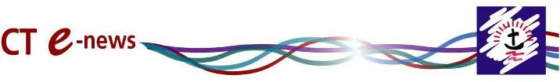
From Churches Together in England
For September and October 2013

Reflection: Three Days of Ecumenical Life
By Rev Dr David Cornick, General Secretary of CTE
It’s been a busy week. CTE & CTBI joined with the British Trust for Tantur in sponsoring a study day on Eastern Christianity, so on Saturday I sat and listened with deep interest to speakers who spoke with passion and insight about the history and present fortunes of the ancient Christian churches of the Middle East who trace their history to the very earliest of Christian times. The picture was at once remote and chastening – these ancient churches which in medieval times made up about half the population of the middle East now account for about 1%. In places like Iraq an ancient Christian tradition is passing slowly but inexorably into history. On the other hand, Bishop Angaelos spoke with passion and hope of the crucial role of the Coptic Church as a community of reconciliation at the heart of the emerging future of Egypt. These ancient churches of the East are part of us, many of them with congregations in England and in membership of CTE.
On Sunday I sat in the congregation at Sutton Coldfield Baptist Church as the Revd Lynn Green was inducted as the new General Secretary of the Baptist Union of Great Britain. A praise band rocked the rafters, informality ruled, and one of the highlights of the service was Lynn kicking off her heels and joining with the children in an action hymn. Here, we were told (and it was obvious) was a deliberately new and different understanding of church leadership. All of us part of the vine, we were told in the sermon, all called to bear fruit.
Three days later, in the company of Catholic and Orthodox friends, I was delighted to be an ecumenical guest in Westminster Abbey at the consecration of my friend and former colleague Jonathan Goodall as Bishop of Ebbsfleet, alongside Martyn Snow as the new bishop of Tewkesbury. Here was the full pomp and splendour of the Church of England as the music of Tallis and Bach echoed sonorously, yet it was also a touchingly personal occasion as two new bishops became part of a college of bishops which stretches back through English history. The service was a eucharist, and as Rowan Williams reminded us in a memorable sermon, the role of a bishop is ‘blindingly simple’, it is to be at the Lord’s Table in the name of the welcoming Christ and say ‘it has been done once, only once and once for all’. The future has been made present. God has done what God has done, and we live in the power of what God has done, pointing to the ultimate reality which is that all the things of earth shall be enfolded into the purposes of God, everything secure in God’s hands.
Bearing fruit, proclaiming that the future is now, living the reconciling love of God even as the suicide bombers wreak their worst and the thugs brandish rifles and put the boot in. (and our prayers are with the Christians of the Middle East and Pakistan). In the midst of the week’s bracing diversity was one underlying reality – living out what it means to be in Christ. It put me in mind of Gerard Manley Hopkins, ‘For Christ plays in ten thousand places/ Lovely in limbs, and lovely in eyes not his/ To the Father through the features of men’s faces.’

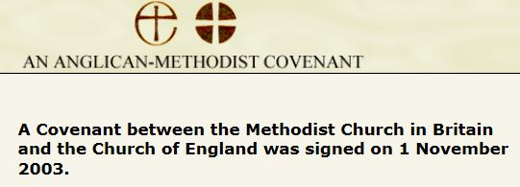
Anglican - Methodist Covenant 10 years on. Sept 2013 Report.

The Challenge of the Covenant: Uniting in Mission and Holiness
The new Report of the Joint Implementation Commission (JIC) of the Covenant between the Church of England and Methodist Church in Britain

“Church leaders and decision-making bodies should make the Covenant a priority in order to bring our Churches closer together in mission and holiness.”

The JIC Report calls on both Churches to consider the impact that the 10-year-old Anglican-Methodist Covenant has made on their relationship to rejoice in the progress that has been made; and to face together the challenges of mission and holiness.
Go to the Anglican - Methodist Covenant website for the full report

Black and Multicultural Churches Directory
Press Statement 1 October 2013
Churches Together in England has today launched the Black and Multicultural Churches Directory, which will be known as the BMC Directory, and is available online.
The BMC Directory aims to become the largest and most accurate listing of black and multicultural churches and supporting organisations in the UK. And it is growing fast! Leaders and administrators of churches and related organisations are encouraged to visit the site, register and look for their listing, amending as appropriate; and if not already listed, add their details free of charge.
Secretary for Minority Ethnic Christian Affairs at Churches Together in England, Bishop Dr Joe Aldred said, 'I am really excited that after further investment in the quality of the information available on this important site and a slight change of name, we have been able to make a new version of this valuable resource available to the general public. Black and multicultural churches are among the fastest growing of the Church in Britain; and having a fully functional interactive online facility with quality information is a real blessing.'

Read the whole Press Release on the CTE website
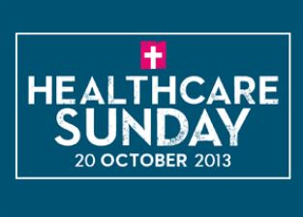
Healthcare Sunday 20th October 2013
Healthcare Sunday was set up over a decade ago as a way to help churches re-engage with health and medicine. For at least one Sunday every year we encourage all churches pray for, encourage and support those in the church who work in healthcare, and remember all those working in local health institutions. But it does not stop with this one Sunday, and we are providing resources and links to other organisations that can help encourage the church to support health workers around the country around the year.
www.healthcaresunday.org.uk
To learn more of what Healthcare Sunday is all about see the video on YouTube

Inter Faith Week 2013... 17-23 November
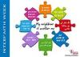
Celia Blackden writes: Only a few weeks to go until Inter Faith Week begins. Once again it presents many opportunities to build good relationships with our neighbours of other religions.
Full information is available through the Inter Faith Week website.
The postcard jpegs "My neighbour is another me" can be downloaded and printed or used in PowerPoint presentations.
The text accompanying the postcards is also available.
www.cte.org.uk/interfaith

DVD tells exciting story of the Northern Saints
A DVD has gone on sale to help people celebrate the rich religious heritage of the North East and its continuing relevance to the modern world.
The Good News for Every Age DVD was commissioned by the North East Council of Churches as a response to the visit of the Lindisfarne Gospels to Durham this summer.
The Council wished to explore how the modern-day churches of the North East are continuing the mission of the Northumbrian saints to bring the message of salvation and good news to the people of the North.
The team behind the project identified a series of locations covering different aspects of contemporary church life and tradition and the DVD tells the story of the early Northern saints and the churches that they founded.
CODEC, a research initiative based at St John’s College, Durham University, was commissioned to deliver the project in time for the Lindisfarne Pilgrimage in July. Among the experts contributing to the supporting materials were David Bryan, Director of Studies at the Lindisfarne Regional Training Partnership, and Rowena Francis, the Moderator of the URC Northern Synod. Financial support came from the people of the North East Churches and SPCK.

Read more on the CTE website – including video links

RE:quest web resource for RE in schools
PRESS RELEASE
New website puts the future of RE at your fingertips
On September 10th Youth for Christ launched a fresh and up to date version of the popular RE website, RE:quest. With high quality films, images, interactive features and age appropriate text the site enables pupils to learn about and learn from the Christian faith.
Established over 12 years ago, RE:quest has become a trusted name throughout UK schools and one of the most used Christian teaching resources across all age groups. Building on this strong foundation, YFC took on the challenge of transforming RE:quest and making it more accessible to today’s classrooms and teaching methods.
Written by, and featuring, Christians from all main denominations in their rich diversity, RE:quest seeks to equip, educate and enable teachers and pupils of all ages and abilities to ask and answer the BIG QUESTIONS surrounding the beliefs and practices that are most important to Christians.

Read the whole Press Release

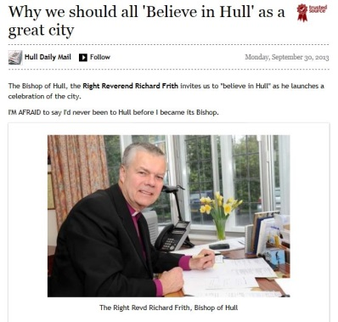
Churches celebrate as 'Believe in Hull' launched
The Church of England Bishop of Hull, Rt Rev Richard Frith, is launching with the help of the Archbishop of York, a two week initiative involving many of the church denominations across the city.
The following text is from the local newspaper Hull Daily Mail for October 2nd 2013:
Yes, I believe in Hull. You will be seeing the words "Believe in Hull" across the city at the beginning of October, because I'm not the only one who believes in Hull. Churches of all sorts are getting together to say how much this city means to them. "Believe in Hull" will be running from Tomorrow to October 13, and there will be events all over the city that all are welcome to attend.
I've said that I love Hull, and I do. This love, though, needs to be expressed in practical action. The churches involved with "Believe in Hull" have been working on a major piece of research with Search (Social and Economic Action Resource of Churches), to examine what sort of community action projects are run by churches, and how they help people in Hull. Like most cities, Hull faces enormous challenges and there are many needs. We've discovered that at least 10,000 people attend or are supported by these social action projects each week. More than 280 projects were recorded in the survey, ranging from Anlaby Park Methodist Church's work in prisons to Community Money Advice, St John Newland's debt counselling service.

Read the whole article online in the Hull Daily Mail

Church of Scotland launches
partnership with Fresh Expressions
Press Release: Tuesday, 1st October, 2013
A partnership between the Church of Scotland and Fresh Expressions, which encourages and supports the development of fresh expressions of church, is officially launched today.
The Fresh Expressions initiative, started in 2004, has seen hundreds of new congregations being formed alongside more traditional churches across the UK and internationally. As an ecumenical movement, its partners include the Church of England, Methodist Church of Great Britain, The Salvation Army and the United Reformed Church.
Plans for the Church of Scotland’s partnership with Fresh Expressions had been jointly formulated by the church’s Mission and Discipleship Council, and the Ministries Council. They have been working together on this issue since 2008 and the Joint Emerging Church Group (JECG) was formed last year.
Colin Sinclair, Convener of the Mission and Discipleship Council, said, ‘There is a need for fresh thinking and trying things that are different because over 90% of folks in Scotland are just not connecting with the church. Not all are hostile to the church and some have had a church background but they need fresh ways to reimagine what they think the church is to be, what the Christian faith is all about and how it could link to their own lives and context.’
The report from JECG, discussed at this year’s General Assembly of the Church of Scotland, highlighted a vision to address the ‘many years of decline across the life of the Church.’ It included an invitation to every parish to explore the possibilities of establishing a new expression of church - appropriate to the local context - by 2020.

Read the Full press Release

'Trust me, I'm a journalist' day conference 16th October
The compact of trust between journalists and the public has never been stretched so thin.
Can it be restored...and if so, how?
Join us at The Church and Media Conference 2013.
Sarah Teather MP has plenty to say about why politicians mistrust journalists and vice versa.
As editor of The Sun David Yelland was close to Tony Blair and Rupert Murdoch.
Dorothy Byrne is responsible for Channel 4 News, Dispatches and Unreported World, making her probably the most powerful person in TV news.
But do we trust them? Do we trust any of them? If not, what can be done about it?
It’s now just two weeks till Trust Me – I’m a Journalist.
We will be meeting on Wednesday, 16 October 2013 at BAFTA, 195 Piccadilly, London W1J 9LN with a series of events through the day.

Full details on CTE website

CUF 'Tackling Poverty Together'
conference 13th Nov
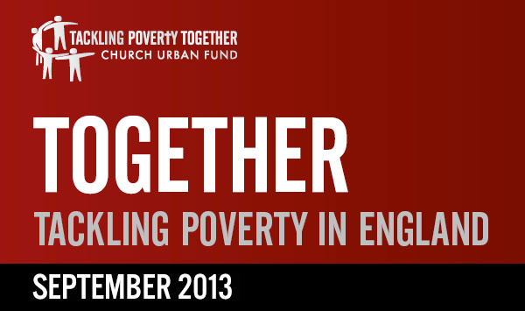
From Church Urban Fund: We are delighted to welcome Justin Welby, Archbishop of Canterbury, as our conference keynote speaker.
The conference will inspire and equip Christians and churches who are working with the poorest people to transform their lives and communities. We want to celebrate and showcase what the church is doing to tackle poverty, and explore how we can respond effectively and appropriately to the needs around us. The day will include workshops on key issues such as asset-based community development, credit unions, urban theology, responding to universal credit and how to recruit and retain volunteers.
Venue, the Old Town Hall, Stratford, home of the Olympics.
Tickets are £10 each, which includes lunch and refreshments.
Booking is now open. Spaces are limited so please book straight away at https://tacklingpovertytogether.eventbrite.com/

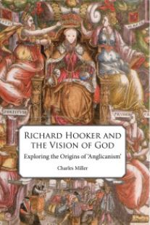
Richard Hooker and the 'Vision of God'
Reviewed for CTE by David Carter
By any standards, Hooker’s Laws of Ecclesiastical Polity was a major theological achievement. It is not however an easy read on account of its long flowing Elizabethan periods. One may, and certainly can, find theological gems in it, but sustained reading is not easy. It is therefore both on that account and for its seminal importance in so much later Anglican thought that it is good to welcome this clearly written and thorough account and appraisal of Hooker’s work, reference also being made to his other occasional writings.
The author, who has taught both in the is country and America, is currently Team Rector of Abingdon. Whilst stressing the overall continuing value of Hooker for Anglicanism, he is careful to locate Hooker clearly in his Elizabethan context, in which moderate Calvinism was still dominant and to show the extent to which Hooker reflected that ethos whilst also asking important questions that had not really been addressed by the earlier reformers.

Read the Review by David Carter on the CTE website

Note about Cte-News
We apologise that no September edition of Cte-News was available, due to illness. We have experimented with a new style of producing Cte-News and would be happy for comments. Jim.currin@cte.org.uk.

Twitter
Follow CTE news on Twitter @churchesengland
………………..

