Sharers, Guests or Tenants?

The Sharing of Church Buildings In the Multi-Cultural City

The Inner City today

Syrian Orthodox, Bethel Korean, Mount Zion Holiness, Vineyard, Byelorussian Orthodox, Jesus Christ of Nazareth, Christ Apostolic, Pentecostal Holiness, Beulah Apostolic, Church of God of Prophecy: - what have such a range of Christian congregations in common? The answer is that they share church buildings with Anglican parish churches in one deanery in West London.  This is a microcosm of church life in many major cities in England, of which London is the most obvious example. The number of ethnic minority churches continues to grow as London becomes ever more diverse in its ethnic make-up. This is a situation of great promise, and yet at times of great friction. The mainstream churches in the inner city are often struggling with large and inefficient church buildings, being maintained by small and elderly congregations. In the same area are often a large number of ethnic minority congregations, some of whom are desperate to find somewhere to worship.  The result is that a high proportion of mainstream congregations in the inner London area – and in many other cities – act as hosts to one or more congregations. In 1994 for example, about 60% of Church of England parishes in the four northern archdeaconries of Southwark diocese hosted at least one, and sometimes up to three “tenant” churches. Even so, there are always more ethnic minority congregations looking for premises. Handled creatively, this situation could be to everyone’s advantage – with a rich diversity of Christian life being sustained in many traditional church buildings, and with the often vigorous and growing black majority churches helping to support the upkeep of church buildings that otherwise would struggle to survive.  Nevertheless there are many tensions. Many complaints have been heard of unhappy relationships and misunderstandings that do no credit to the Church as a whole. Some black Christians’ experience is that they are often not treated as brothers and sisters in the body of Christ – frequently a “landlord-tenant” relationship has grown up.  The situation is not all gloomy. A good many sharing situations continue without friction and to mutual advantage. Nevertheless some of these could be exploited to develop a fuller sense of koinonia in the body of Christ. | “We have been happy to have another church group making use of our premises – this has provided them with a much needed venue for worship and for us has improved the level of utilisation of our premises and provided a useful source of income. Occasionally we have to remind our friends to ensure that lights are switched off, premises are left as found and sound levels of music are kept low.”  “Many problems arise concerning cleaning of premises. The users frequently leave property untidy and dirty. After complaints it improves for a while and then deteriorates. In general though, relations are friendly. The financial gain is valuable to us.”  “They (the ‘guest’ church) use it so much now that it is getting difficult for us to start anything new without curtailing the use and so risking the loss of 50% of our church income! However, we are beginning to do some joint things eg ‘Work through the Bible’.”
Underlying theological issues  Different understandings of the local church  There are two basic understandings of what it means to be “church” – the “parish” and the “gathered” model. The former undergirds Anglican and Catholic churches. There is a sense of pastoral responsibility towards the local community, which in turn has a sense of ownership towards its parish church. The “gathered” church is more natural to non-indigenous and non-traditional church groups. Its emphasis is more on “doing” church, meeting as a gathered community from far and near. Many people will travel many miles to be part of the fellowship, and will have no particular contact with the community in which the church building is placed. This leads to a lack of commitment to the surrounding community.  Different attitudes to mission  A church leader from one of the black majority churches defined mission as primarily about:  - Exalting and honouring the name of God  - The physical presence of a strong and vibrant worshipping community  - Preaching and teaching the Word of God  - Offering the Eucharist  - Baptising of believers  - Acceptance of believers into fellowship.  Compare this with the “five marks of mission” – originally set out by the Lambeth Anglican Conference in 1988, and now used widely ecumenically:-  - Proclaiming the good news of the Kingdom  - Teaching, baptising and nurturing new believers  - Responding to human need by loving service  - Transforming unjust structures of society  - Striving to safeguard the integrity of creation and sustaining and renewing the life of the earth.  In practice many black-majority churches are deeply involved in social issues in their community, and in wider issues of peace and justice; and many mainstream churches are far from engaged in the range of issues described by the “five marks of mission”.  Different attitudes to worship  It is obvious that attitudes to worship reflect the culture and background of the worshippers, and different theologies about worship itself. Some convictions are held on the basis of preconceptions and generalisations, which can only be changed by deeper experience of one another.  Churches differ too in their attitude to the sacred and the profane, to the relationship between the spiritual and the physical, and in different attitudes to the concept of “sanctuary”.  Behind these differences, it is important to remember that many “mainstream” congregations in the inner city have a high proportion of black people in their congregations; that whilst many black-majority churches have a reputation for freedom and spontaneity in their worship, there is also a strong sense of order beneath the apparent freedom; and that there is as great a variety of theological outlooks and styles of worship in black-majority churches as there is in mainstream churches.  Accepting one another within the body  One over-riding issue ought to be influencing all sharing situations – namely that each Christian congregation should regard the other as part of the body of Christ, and should be looking to develop a sense of fellowship and koinonia with them, exploring the whole idea of the richness of diversity. The landlord-tenant relationship is not appropriate within the body of Christ. There should surely be a different spirit between the sharing of church premises between two Christian congregations and the letting of church premises to a badminton club or a keep-fit class.  The need for a wider strategy  This document is only the latest in a series that have attempted to produce better practice and better relationships. But all the paper and the print in the world will not produce better relationships unless we can find people who can help to resolve difficulties, and bring about reconciliation when relationships have broken down.  In the areas of the country where the sharing of church buildings is a lively issue could a team of people be invited to train to become effective mediators? They could be available to help in situations where there is a breakdown or difficulties in relationships; people who could be trusted to be involved helpfully when called upon. Such a team needs to have an equal number of black and white people, and where there is a breakdown between a white mainstream congregation and a black one, a team of two can be invited in.  Such a team needs training, accountability, and the authority to act effectively: a challenge for ecumenical intermediate bodies. | “Advantages: sharing fellowship in a wider multi-cultural context; opportunities for joint services; support of one another’s missionary foci. Disadvantages: none so far with this church. However previous sharings have not been so successful due to an unwillingness from the other church to be in relationship and partnership for reaching out to the community.”  “Charismatic churches were offended by the profane uses to which hall premises were put, such as Martial Arts Groups, Keep Fit clubs, children’s uniformed organ-isations, rowdy parties, dog training classes and so on. They felt that the users of church premises should be Christians, and show some respect for what churches stood for.”  “The worship of these churches depended on the creation of a worshipful atmosphere – through music, ecstatic prayer, stirring preaching and enthusiastic response on the part of the participants. This often struck the host church members as very loud, particularly when services took place late at night as was sometimes necessary due to the unsocial hours that church members had to work.”  “Church members often found host-church members to be cold and unfriendly. If there was some problem, a type-written letter would appear, often very dictatorial in tone. Occasionally invitations to different services or functions were received, but church members felt that these were either money-raising affairs or set piece services where their presence would be largely as pew fodder to impress visitors.”  “What church members would prefer would be regular meetings for prayer on an equal footing in which there could be mutual encouragement and genuine waiting upon God, rather than the formality of business type meetings which host church members seem to prefer.”  “This is not just a practical issue – about sharing the cost of church buildings. It is a justice issue – about how people of different races are treated in the body of Christ; and it is an ecumenical issue – about recognising each other as brothers and sisters in Christ.”
At the meeting of Churches Together in England’s Group for Local Unity in May 2000, this paper was discussed and commended to the churches. In particular it is hoped that Intermediate Bodies with many black-majority congregations in their area will take initiatives to spread the Principles of Good Practice (overleaf), and consider setting up a team of mediators, as part of a wider strategy (above).
Further copies of this four-page document are available from the CTE London office, 27 Tavistock Square, WC1H 9HH (020 7529 8141) and on the CTE website www.churches-together.org.uk.

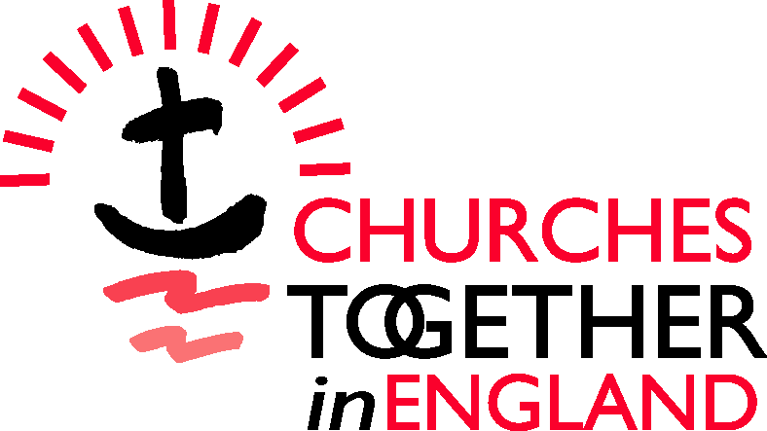

Principles of Good Practice : living “unity in diversity”

1 the agreement between the congregations. Whilst the early stages of reaching such an agreement will often be informal and verbal, any arrangement needs to be set out in a written document that both sides agree and sign. For a long-term agreement with considerable financial and other aspects, a proper Sharing Agreement under the Sharing of Church Buildings Act 1969 is more appropriate. The essential point is that both sides should have a written basis for the agreement which is regularly reviewed.

2 the relationship between the leaders. Experience shows that it is not enough for the leaders of the congregations to agree to meet only when problems arise; it is important to have a scheduled and regular meeting – perhaps monthly or bi-monthly – when any small issues can be raised before they become larger irritants. Action agreed upon should be minuted in writing, and checked at the next meeting.
When leaders of either congregation are leaving or arriving, it is common courtesy to inform the other; an “exit” meeting and an “incoming” one between the leaders should be natural.

3 the relationship between the congregations. Granted that different cultures and traditions make it unlikely in most cases that two or more worship services can be permanently unified, can special arrangements be made for members of one congregation to visit the other and be welcomed? If this “getting to know you” process is left to chance, the chances are it will never happen. Perhaps a year’s programme of mutual visiting could be agreed, and at the end whatever was learned can be assessed.

4 the details of any sharing agreement.

(a) Timing. A constant source of irritation is different attitudes to time. Some black-majority church services and weddings tend to start some time after the advertised time, and often go on for longer than people from “mainstream” congregations would expect. Realistic time for cleaning up afterwards needs to be allowed for.
- Noise. The use of amplified equipment is very common in many black-majority churches – this can be a source of irritation to local residents. Similarly the noise of car doors and car engines late at night has been known to cause friction, even in one case in South London leading to legal action by local residents.
- Cleanliness and order. Who is responsible for cleaning the premises? Is there adequate storage space available, and is it used?
- Finance. Buildings cost money to run – there is heating, lighting, insurance, repairs and maintenance to be dealt with. What is the fairest and most realistic way to deal with this, between two or more users? Sometimes the “host” congregation needs to explain in more detail what it costs to run the premises. A greater openness and realism would be consistent with the sense that all are part of the body of Christ.
- Access and closing arrangements. Caretakers need to be involved in the spirit of all agreements, and perhaps in regular meetings as in (2) above. Can the users of any premises be given a set of keys?
- Signboards outside the church. If more than one congregation is using the premises, should not the timing and details of all services be announced on the notice board – and care given to the way in which this is presented? Can the notice boards, and indeed all publicity relating to the church services, present an image of a true “unity in reconciled diversity”? The positive effect on race relations could be considerable.

© Churches Together in England 2001 |  | Charity No 1005368

