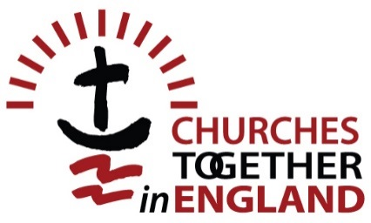
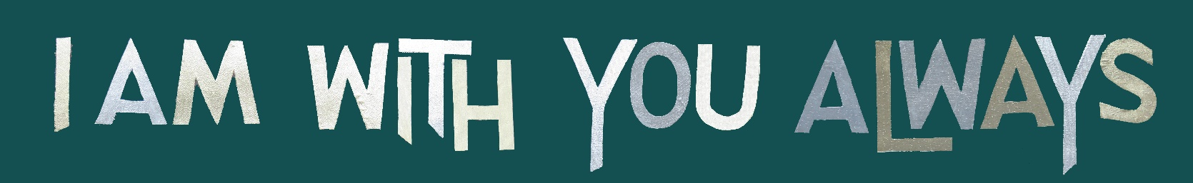

Forum 2018

Monday 17 to Wednesday 19 September 2018
at The Hayes Conference Centre, Swanwick, Derbyshire.
Tel: 01773 526000

'I am with you always'

– together in God's mission –

Small group questions for the Presidents

Tuesday 18 September Small group session 10.55 am to 11.40 am

- How can the churches, together, fulfil the Ministry of reconciliation in such a divided country as is Britain in the light of Brexit?
- Does it matter if different prophetic voices – drawing from the same gospel – say different things when speaking into society?
- We are grateful for the glimpse into the relationships of trust between the Presidents. What more are the Presidents going to do to demonstrate this publicly in the next three years and so help encourage the same to happen at the local level?
- How do the other churches support those churches who are "in the valley" and express our support and unity, remembering that we are all children (brothers and sisters) of Christ so that the world can see our unity in the Lord?
- How do the churches be more confident or sit comfortably as themselves in the midst of the many tensions that surround us/exist within us? And how can we find alternative methods to measure "success" that don't rely on "numbers on Sunday "?
- How can we ensure that the next six Presidents are not all men, to show diversity?
- How do we become more intentional about diversity in its fullest terms?
- How can we be relevant to the world outside the church when the CTE Presidents are all male?
- In the context of Jesus cleansing the temple and turning over tables, what table would you overturn in your own denomination?
- Give an example of a local ecumenical initiative that started very badly (division, procedural issues, etc) that came good?
- To help wean the churches off the anaesthetic, how will you personally think, speak or lead differently as a result of the forum?
- Denominational identity especially in single congregation LEPs. How do "rainbow coloured children" who identify as Christian but with no denominational identity fit in? When one feels called to ministry they have to choose.
- While we acknowledge that structure sometimes hinders our Kingdom mission, how can we grow trust among us, so enabling mission to grow?
- Why was there a division between the two President groups – traditional Monday and new church Tuesday?
- How do we build on the positive and friendly relationships shown here at Forum and between the Presidents to encourage (ecumenical) work in the wider church which will not be halted by the legalities of our denominations?
- How can we communicate the unity we are seeing with the Presidents, at grassroots level?
- What can we all do, at all (local, intermediate and national) levels, to shine forth the energy and exciting life of the spirit we are experiencing here? Please give practical examples.
- At what point can we move from being churches together in England to the church together in England? What is your strategy for achieving that?
- How do we effect an ecumenical culture shift at the local level? How do we get our local Churches more involved in ecumenical work?
- How can we bridge the gap between aspiration and reality for ecumenism, at all levels within a church?
- Can the structures of CTE (which captures great diversity) both anaesthetise us to the pain of theological divisions and build on that great diversity?
- How can the very positive relationship between all six Presidents be translated to the grassroots so that they know the transforming presence of Christ?
- How can we support you?
- As churches, can we, and how do we, allow God to work through our weaknesses, rather than our strengths?

