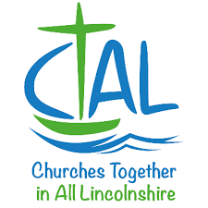

MISSION ENABLER

Churches Together in All Lincolnshire, (CTAL), is seeking to appoint a, ‘Mission Enabler’, to work with church leaders, churches, denominations, and other appropriate groups across the region of Lincolnshire, North Lincolnshire, and North East Lincolnshire from April 2021. This is a paid, part-time post, (18hrs per week), with a degree of flexible working.

The post holder will:
- Encourage and develop ecumenical working in the mission and growth of God's Kingdom throughout the region
- Enable good communication between denominations, churches, local CT groups, and other partners
- Coordinate the various meetings and activities of CTAL

The successful applicant will have:
- A strong faith in Jesus Christ and good standing with a local church
- Enthusiasm and skills to facilitate Christians working together in mission
- Good communication skills, including IT and administration
- An understanding of, and prior involvement with, working ecumenically
- Self-discipline, and the ability to organise and prioritise their own workload

If this describes you, and you are interested in the post, please access further details on the CTAL website www.ctal.org.uk before submitting your CV and covering letter to admin@ctal.org.uk

Closing date for applications is Friday 19th February
Interviews will be held via zoom on Thursday 25th February

