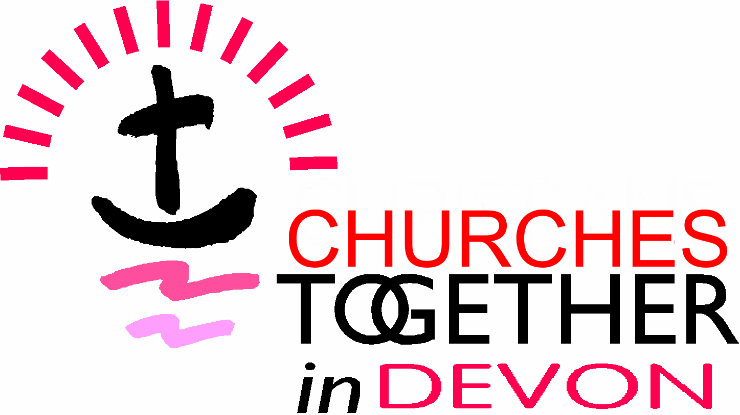
County Ecumenical Officer for Churches Together in Devon
Part - time post (16 hours a week)
Job Description
Overview
The County Ecumenical Officer (CEO) is the executive officer of Churches Together in Devon (CTD), accountable to, and administering the charity on behalf of, the Trustees. The main purpose of the role is to encourage and support churches in Devon in co-operation and visible expression of Christian unity. A key aspect is enabling good communication between the Churches, ecumenical groupings and other partnerships in Devon. The work involves flexible hours, which may vary from week to week, including some evenings and weekends.
Geographical scope
Churches Together in Devon operates across (the local authority areas of) Devon County, Plymouth and Torbay, and the term “Devon” is used here to refer to this wider area. The CEO will work from home, which should be in or very close to the borders of Devon, and travel as necessary across Devon and sometimes beyond.
Accountability
The CEO is accountable to the Trustees of Churches Together in Devon, charity number 1126079 (the employer). The Trustees will arrange effective line management and support for the officer, including a regular meeting with the Chair of CTD and an agreed work plan.
Tasks
- Administer Churches Together in Devon: Organise and minute the meetings through which the work of the charity is taken forward, including, but not limited to, meetings of the Trustees. Support the Chair and Treasurer in ensuring that CTD complies with legal and governance requirements. Manage the work of volunteers and contractors. Ensure proper storage of records. Draft the annual report for approval by the Trustees.
- Promote local expressions of Christian unity: Encourage local Churches Together or Christians Together groups throughout Devon, sharing good practice and signposting resources. Facilitate the response of Churches Together in Devon, on behalf of the member Churches, to major housing developments.
- Nurture missional networks: Work with Church leaders in Devon, church representatives to strategic groups, and other Christian networks and agencies with a Devon-wide remit, to facilitate collaboration with public and voluntary agencies for the common good. (The main focus of this task is the County of Devon, as within Plymouth and Torbay the local Churches Together groups are able to take on this role.) The role of the CEO is to encourage a network of representation and collaborative style of working among Christians, including those churches not at present in membership of CTD. Direct participation on external bodies will be limited, subject to time priorities agreed with the line manager.
- Support Local Ecumenical Partnerships: Co-ordinate the work of CTD as sponsoring body to Local Ecumenical Partnerships within Devon. Detailed work with an existing or proposed LEP will normally be undertaken by the relevant Denominational Ecumenical Officers (DEOs) in consultation with their Church leaders. The CEO role is to co-ordinate this, drawing on Churches Together in England guidance and prompting timely reviews. The CEO will source further advice or volunteer support where needed; brief Trustees on the overall position; and hold a central record of key documents and decisions relating to LEPs.
- Enable communication: Establish and maintain communication channels which support the objectives of CTD, in particular sharing examples of local unity and signposting new initiatives and resources. Oversee all communications in the name of CTD, including the website, news bulletins and social media presence. (The CEO may engage volunteers and, within budget, commission professional help with communications, but retains responsibility for the scope and suitability of content.)
- Liaise with national ecumenical bodies: The CEO works in the context of a network of similar officers in other areas of England, and will keep in touch with others in the south west region, and with Churches Together in England (CTE) national staff. They are expected to attend CTE’s induction training and annual conference for CEOs; to select items from the CTE news updates to highlight in local communications, and to brief CTD Trustees on recommendations from CTE or Churches Together in Britain and Ireland which require a local response.
- Organisational development: Support the Trustees in periodic review of CTD’s goals and approach to achieving them. CTD is in the course changing its constitution and structures, and the appointee will help to see this through.

