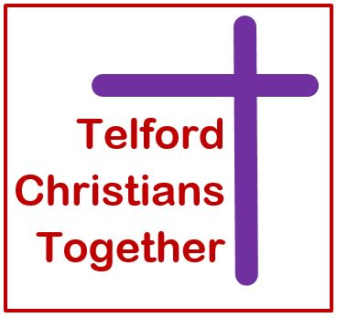
CHURCHES
TOGETHER in partnership with
IN SHROPSHIRE

Ecumenical Mission Enabler

The person appointed will be a mature Christian person who has the personal skills to enable mission in an ecumenical context.
The following indicates the qualities Telford Christians Together and Churches Together in Shropshire are looking for in this appointment.

 | Essential | Desirable
Qualifications
Educated to graduate level or higher , theologically literate
Experience
A well developed understanding and experience of ecumenism
Proven experience of managing people and resources
Have experience of leading project management and sourcing funding
Skills/Knowledge
Self-motivated, ability to prioritise, set own agenda, organise own time and work on own initiative with confidence / time management
Knowledge of Contemporary Mission across the churches
Able to relate to a wide variety of church traditions and individual theologies
Able to work with both lay and ordained Christian leaders and congregations
IT literate, able to communicate effectively across a range of media, to give presentations and speak to groups concisely and clearly, in and outside the church context – computer literate.
An understanding of rural, suburban and urban churches and how they differ
Personal
Be a committed Christian and a member of one of the churches of Churches Together in England
A passion for mission evangelism and church growth – infectious enthusiasm
Demonstrate imagination, creativity and innovation
Good at listening and networking
General
Hold a full, valid, UK driving licence and vehicle insured for business use

