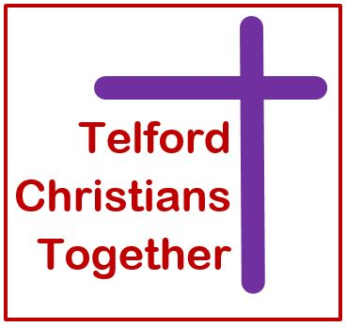

MISSION STATEMENT

A Way Forward for Telford Churches
‘Telford Christians Together’

Telford Christians Together is a rebrand of Telford Christian Council which recently agreed the following statements:

The Vision Statement
Telford Christians Together is a meeting point of followers of Jesus Christ which exists to communicate, motivate and facilitate the mission and ministry of the Gospel through the Churches in the Borough of Telford & Wrekin.

The Mission Statement
Telford Christians Together will be an effective umbrella body for the wider mission activities and projects of the Churches and Christian agencies across the Borough of Telford and Wrekin.

