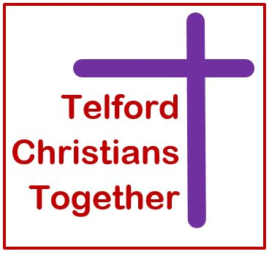
CHRISTIANS
TOGETHER in partnership with
IN SHROPSHIRE

MISSION ENABLER

JOB DESCRIPTION

LOCATION:

Primarily based at Meeting Point House, Southwater Square, Telford, and with the expectation to work throughout the county of Shropshire.

HOURS PER WEEK:
The role is made up of two distinct 18 hours posts totalling 36 hours per week. Hours need to be flexible with some evening and weekend meetings/events. 18 hours are allocated to Telford Churches Together (TCT) and 18 to Churches Together in Shropshire (CTS).

RESPONSIBLE TO:
TCT Executive Committee through the chair, who will meet with the Mission Enabler on a regular basis and will put into place effective line management and support. TCT will process the payroll.

GENERAL:
TCT is the umbrella body for all Christian Churches in the Telford area formed from the restructuring of Telford Christian Council. TCT is committed to ecumenical working amongst the Churches of Telford and developing the mission opportunities arising from the continuing demographic expansion of Telford. This is a newly funded post reflecting the intention of both TCT and CTS to enable churches to become more mission focused and outward looking as they share the Gospel. It represents an exciting, collaborative venture and underpinning the project is an objective to realise the vision of the Telford and Shropshire Churches. It is envisaged that the Mission Enabler will encourage, enable and when necessary challenge churches and groups of churches.

PURPOSE OF JOB:
To work closely with and for TCT and CTS to support ecumenical work and to stimulate and encourage churches to work together in mission.

To encourage and inspire both churches and groups of churches to embrace the dynamic nature of Christ’s Mission today; in transforming the world for God through life-changing, community-changing and society-changing action.

PRINCIPAL RESPONSIBILITIES:
In the Telford area, working as part of TCT:-

- To promote and raise the profile of TCT across Telford area.

- To work with the Executive Committee to formulate an Action Plan to ensure TCT achieves its Mission Statement.

- To build positive relationships with local Churches Together groups and associations of churches making them aware of the Action Plan and ensuring their buy-in.

- To develop ecumenical relationships between the established churches and with emerging churches, especially BME Churches and also with other faith groups and organisations within the Borough.

- To work alongside Co-ordinating Chaplain, who is released by Madeley Baptist Church for three days per week to fulfil this role on behalf of TCT.

- To line manage the Resources Officer when appointed.

- To undertake any other tasks and responsibilities as directed from time to time by the Executive Committee of TCT.

In the rest of Shropshire, working as part of Churches Together in Shropshire:-

- To work with local Churches Together groups and associations of churches, recognising the strengths and weaknesses of these bodies and assisting weaker ones to benefit from the strengths of others; actively networking with these groups and sharing good practice and successful mission enterprises.

- To encourage and enable able local Christians to re-establish Churches Together groups where necessary.

- To act as a resource for the local churches, Churches Together groups and associations of churches, attending regional and national conferences and keeping abreast of current thinking on ecumenical mission and initiatives.

- To support and enable the work and mission of Local Ecumenical Partnerships (LEPs) and assist them in their activities as they develop their mission.

- To develop ecumenical relationships between the traditional churches and emerging churches.

Areas of overlap/combined responsibility:

- To represent both TCT and CTS in Shropshire when attending county-wide Mission initiatives, for example ‘Shropshire Hope’.

- To encourage and promote a range of evangelistic endeavour across the county, at a strategic and operational level.

- To assist the Churches at all levels in the Telford and Shropshire area to work more closely together.

- To value the ministry of both lay and ordained leadership and be able to demonstrate the ability to work effectively with the whole people of God for the Mission of God.

- To work effectively as a networker and demonstrate an awareness of the field of mission at local, regional and national levels, providing advice on appropriate resources available to support church growth and mission within the county.

- To relate to the twice yearly Church Leaders meeting. Acting as a resource to the meeting by being fully conversant with national ecumenical matters and concerns and where appropriate implementing actions arising from these meetings.

